Surrey Hills Baptist Church

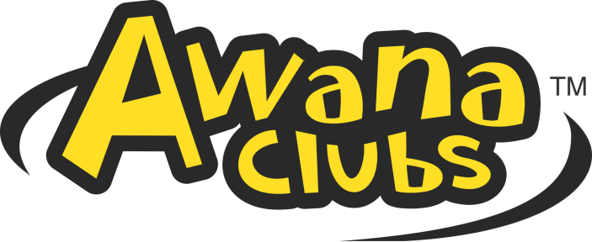

2024 - 2025 Schedule

September January
September 4 – Registration Night! January 1 - No Meeting/Christmas Break
September 11 January 8 – Cubbies & Sparks K Store
September 18 January 15 – Pajama Night Sparks 1st & 2nd Store
September 25 January 22 – 3rd & 4th Grade Store
January 29 – 5th & 6th Grade Store

October February
October 2 – Cubbies & Sparks K Store February 5 – Cubbies & Sparks K Store
October 9 – Pajama Night; Sparks 1st & 2nd Grade Store February 12 – Goofy Glasses & Mustaches; Sparks 1st & 2nd Store
October 16 – No Meeting/Fall Break February 19 – 3rd & 4th Grade Store
October 23 – 3rd & 4th Grade Store February 26 – 5th & 6th Grade Store
October 30 – 5th & 6th Grade Store
November March
November 6 – Cubbies & Sparks K Store March 5 – Cubbies & Sparks K Store
November 13 – Super Hero Night; Sparks 1st & 2nd Store March 12 – Crazy Hair Night; Sparks 1st & 2nd Store
November 20 – 3rd & 4th Grade Store/5th & 6th Grade Store March 19 – No Meeting/Spring Break
November 27 – No Meeting/Thanksgiving Break March 26 – 3rd & 4th Grade Store/5th & 6th Grade Store

December April
December 4 – Cubbies & Sparks K Store April 2 – Cubbies & Sparks K Store
December 11 – Bling-It-Out Christmas; Sparks 1st & 2nd Store April 9 – Favorite Color Night; Sparks 1st & 2nd Store
December 18 – T&T Store April 16 – 3rd & 4th Grade Store
December 25 – No Meeting/Christmas Break April 23 – 5th & 6th Grade Store
April 30 –

May
May 7 – Cubbies & Sparks K Store May 14 – Western Night; Sparks 1st & 2nd Store
May 21 – T&T Store

- Dress-up nights are indicated in BLUE and will be held the 2nd meeting of each month.
- Cancelled meeting dates are indicated in RED. No clubs will be held on these dates.
- AWANA Store nights are indicated in GREEN and are held on a different night for each club.
1st Wednesday – Cubbies & Sparks K Store Nights
2nd Wednesday – Sparks 1st and 2nd Store Nights
3rd Wednesday – 3rd & 4th Grade Store Nights
4th Wednesday – 5th & 6th Grade Store Nights

